Conferences : Asia Pacific
Conference Updates page and
ISA AI Home page (both)

ISA Asia Pacific Tokyo Conference, 2023 will be held at Waseda University, Tokyo at August 8-10, 2023, two years later after Tokyo Olympic 2021.
We expect 400-500 researchers will have presentations, including graduate students’ poster sessions. We hope to join face to face excellent meeting together after Covid-19. If the situation of Covid will be difficult, we consider the hybrid meeting as well, but main Conference will be face to face until now.
The title is: Global Role of Asia-Indo Pacific in International Relations : Anthropocene, Peace and Security. Please join us, from all over the world!
The submission deadline is February 15, 2023.
We would like to collaborate with other Regions, Sections and Caucuses!
All Graduate students including Master course students also will be able to apply. We could support the funds to help several graduate students who have presentations from developing countries
- Venue : Waseda University, Tokyo https://www.waseda.jp/top/en/access/waseda-campus
From air port: From Narita, From Haneda
- Opening Session, Keynote Speech:
At Ibuka International Congress Hall
https://www.google.com/search?q=%E4%BA%95%E6%B7%B1%E3%83%9B%E3%83%BC%E3%83%AB%E3%80%81%E6%97%A9%E7%A8%B2%E7%94%B0&rlz=1C1CHZN_jaJP917JP917&oq=%E4%BA%95%E6%B7%B1%E3%83%9B%E3%83%BC%E3%83%AB%E3%80%81%E6%97%A9%E7%A8%B2%E7%94%B0&aqs=chrome..69i57j0i546l5.8011j0j15&sourceid=chrome&ie=UTF-8#lpg=cid:CgIgAQ%3D%3D,ik:CAISFjVqM2lLVmhEOEp5aXRIUTBjNmhSNnc%3D
- Reception: Rihga Royal Hotel Tokyo https://www.rihga.co.jp/tokyo/party
- Panels, Posters, and Exhibitions: Building of School of Political Science and Economics, Waseda University
https://www.waseda.jp/top/news/13443
(Please open several pictures)
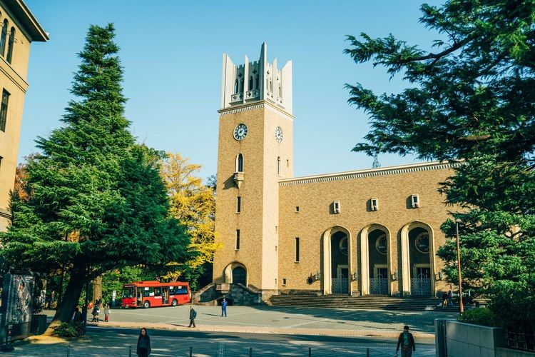
Waseda University
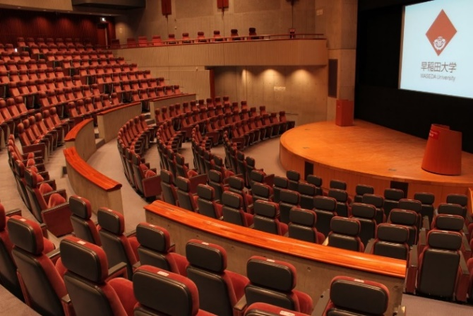
Ibuka International Congress Hall
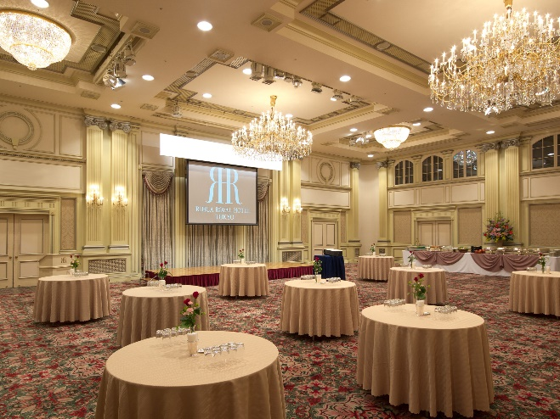
Rihga Royal Reception Room
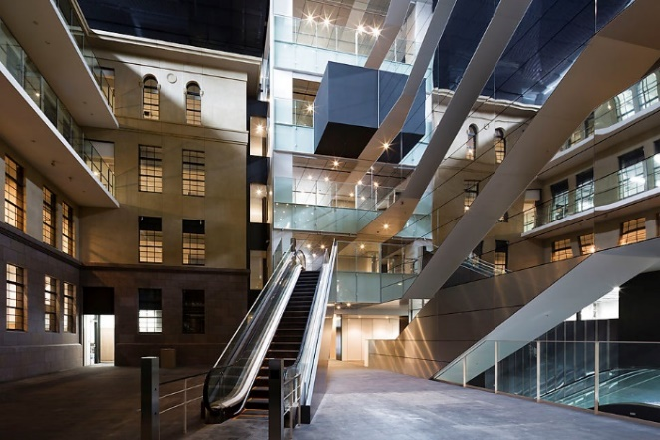
Building of School of Political Science and Economics: Third Building

